**TEHREEM ZUBAIR**

**BYTEWISE FELLOWSHIP**

**TASK 1**

**INSTALLATION AND SETUP**

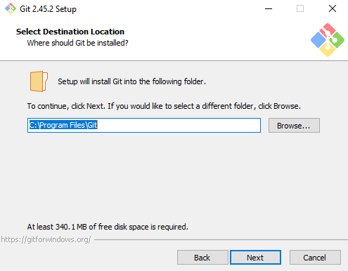 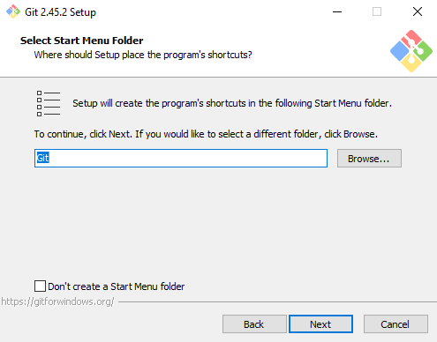

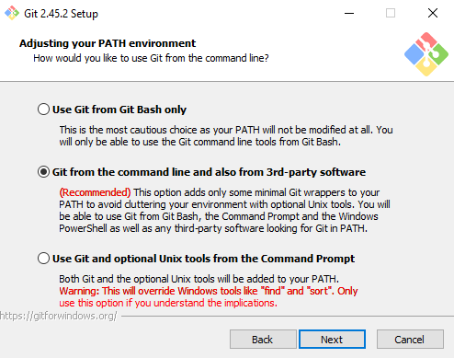 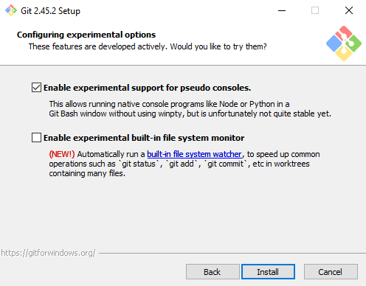

 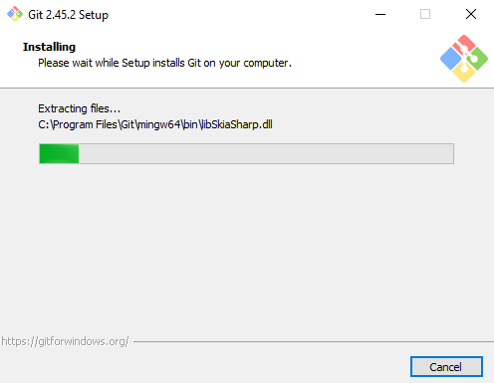

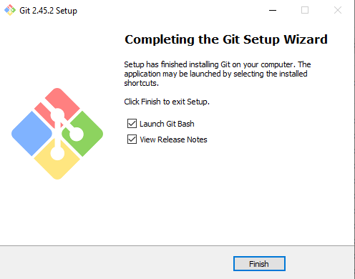

**GIT COMMANDS:**

1. **CONFIGURE GIT**

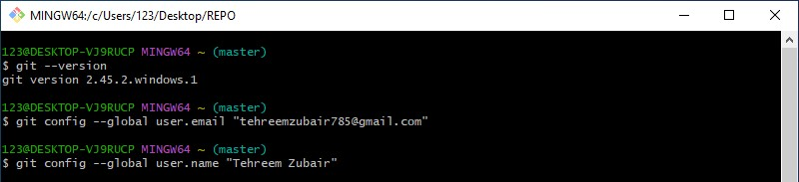

1. **CREATING GIT FOLDER + INITIALIZE GIT**

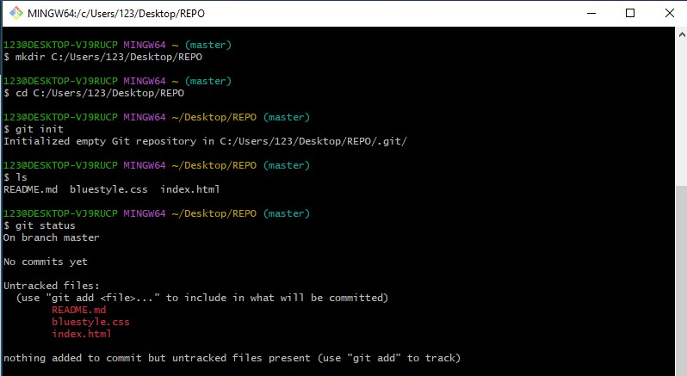

1. **GIT ADD FILES + GIT COMMIT**

